Name:- Sanvi Wadhankar
PRN:- 24070521191
SEM:- 4th

PRACTICAL 6 PART 1 TASK

1. Write a PL/SQL program to check whether a number is divisible by 5.

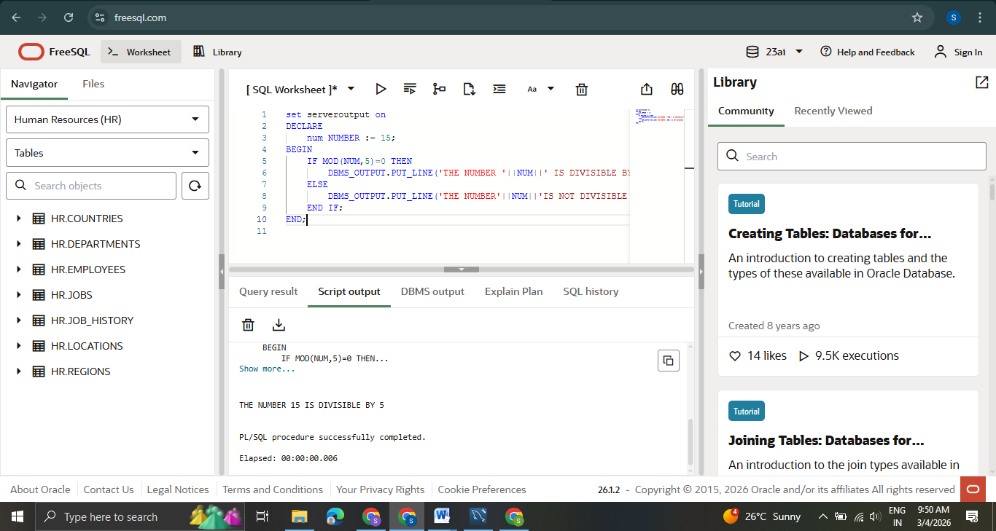

2. Modify the grade program to include more conditions (e.g., 60-70 for D, below 60 for F).

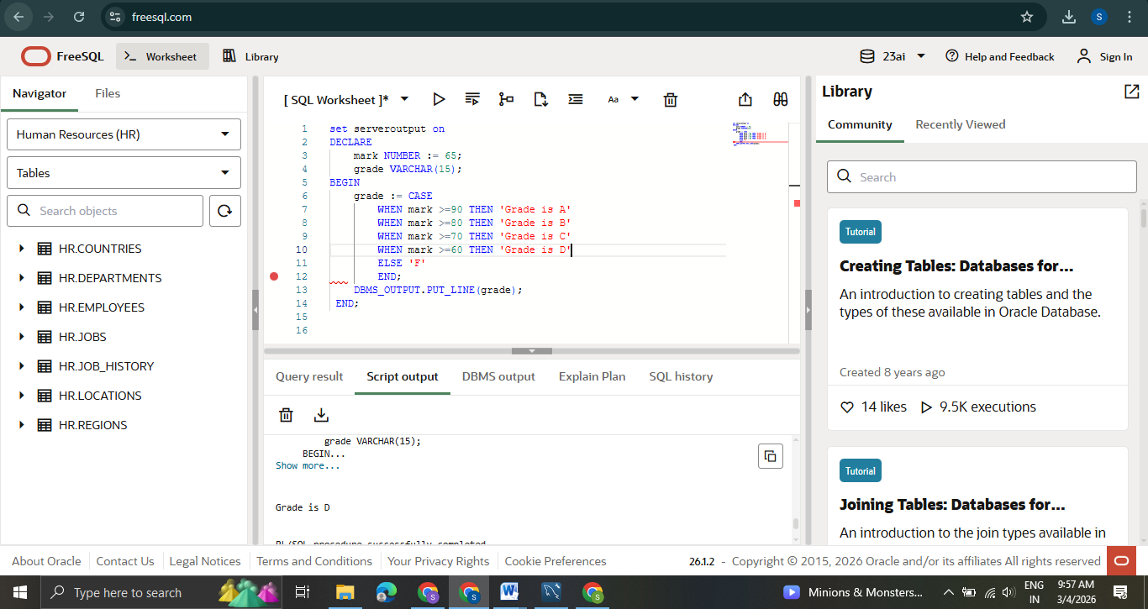
set serveroutput on
DECLARE
num NUMBER := 60;
grade VARCHAR(15);
BEGIN
grade := CASE
WHEN num >= 90 THEN 'A'
WHEN num >= 80 THEN 'B'
WHEN num >= 70 THEN 'C'
WHEN num >= 60 THEN 'D'
ELSE 'F'
END;
DBMS_OUTPUT.PUT_LINE(grade);
END;

3. Write a CASE statement to display the day of the week based on a number input (1 = Monday, 2 = Tuesday, etc.).
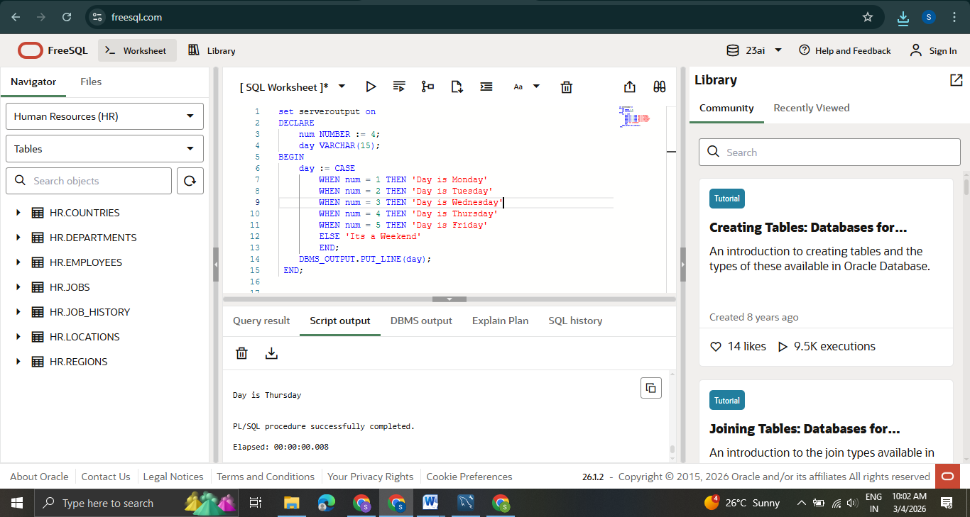

set serveroutput on
DECLARE
num NUMBER := 4;
day VARCHAR(15);
BEGIN
day := CASE
WHEN num = 1 THEN 'Day is Monday'
WHEN num = 2 THEN 'Day is Tuesday'
WHEN num = 3 THEN 'Day is Wednesday'
WHEN num = 4 THEN 'Day is Thursday'
WHEN num = 5 THEN 'Day is Friday'
ELSE 'Its a Weekend'
END;
DBMS_OUTPUT.PUT_LINE(day);
END;
4. Create a program that checks the largest of three numbers using IF-THEN-ELSIF.
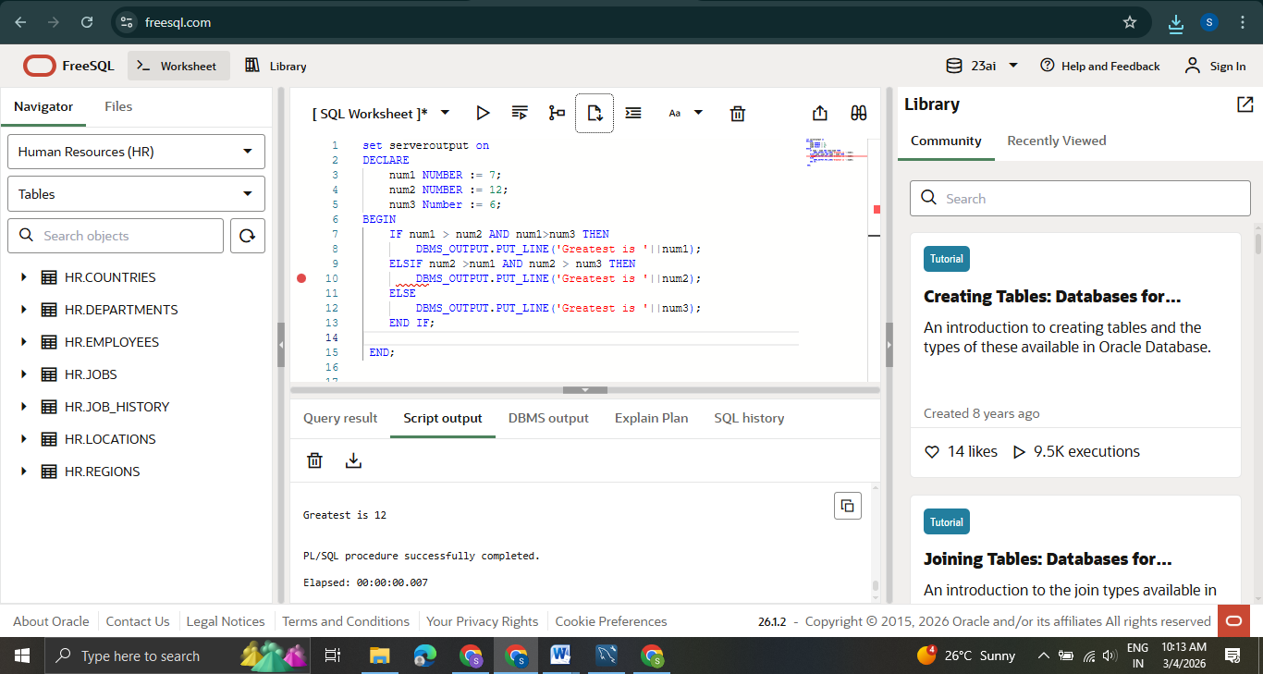
set serveroutput on
DECLARE
num1 NUMBER := 7;
num2 NUMBER := 12;
num3 Number := 6;
BEGIN
IF num1 > num2 AND num1>num3 THEN
DBMS_OUTPUT.PUT_LINE('Greatest is '||num1);
ELSIF num2 >num1 AND num2 > num3 THEN
DBMS_OUTPUT.PUT_LINE('Greatest is '||num2);
ELSE
DBMS_OUTPUT.PUT_LINE('Greatest is '||num3);
END IF;

END;

